**The Neural Basis of Decision-Making – Assignment Part A**

In this section, you will be analyzing data obtained in freely moving mice that were performing a task that was designed to measure dopamine reward prediction error (RPE) coding.

In this task, mice were placed in a box with two water reward ports. The mice had to alternate between ports and nose-poke (insert their noses into the ports) in order to receive rewards in a **forced choice** design, meaning that they **had** to alternate, and consecutive attempts at the same port were never rewarded.

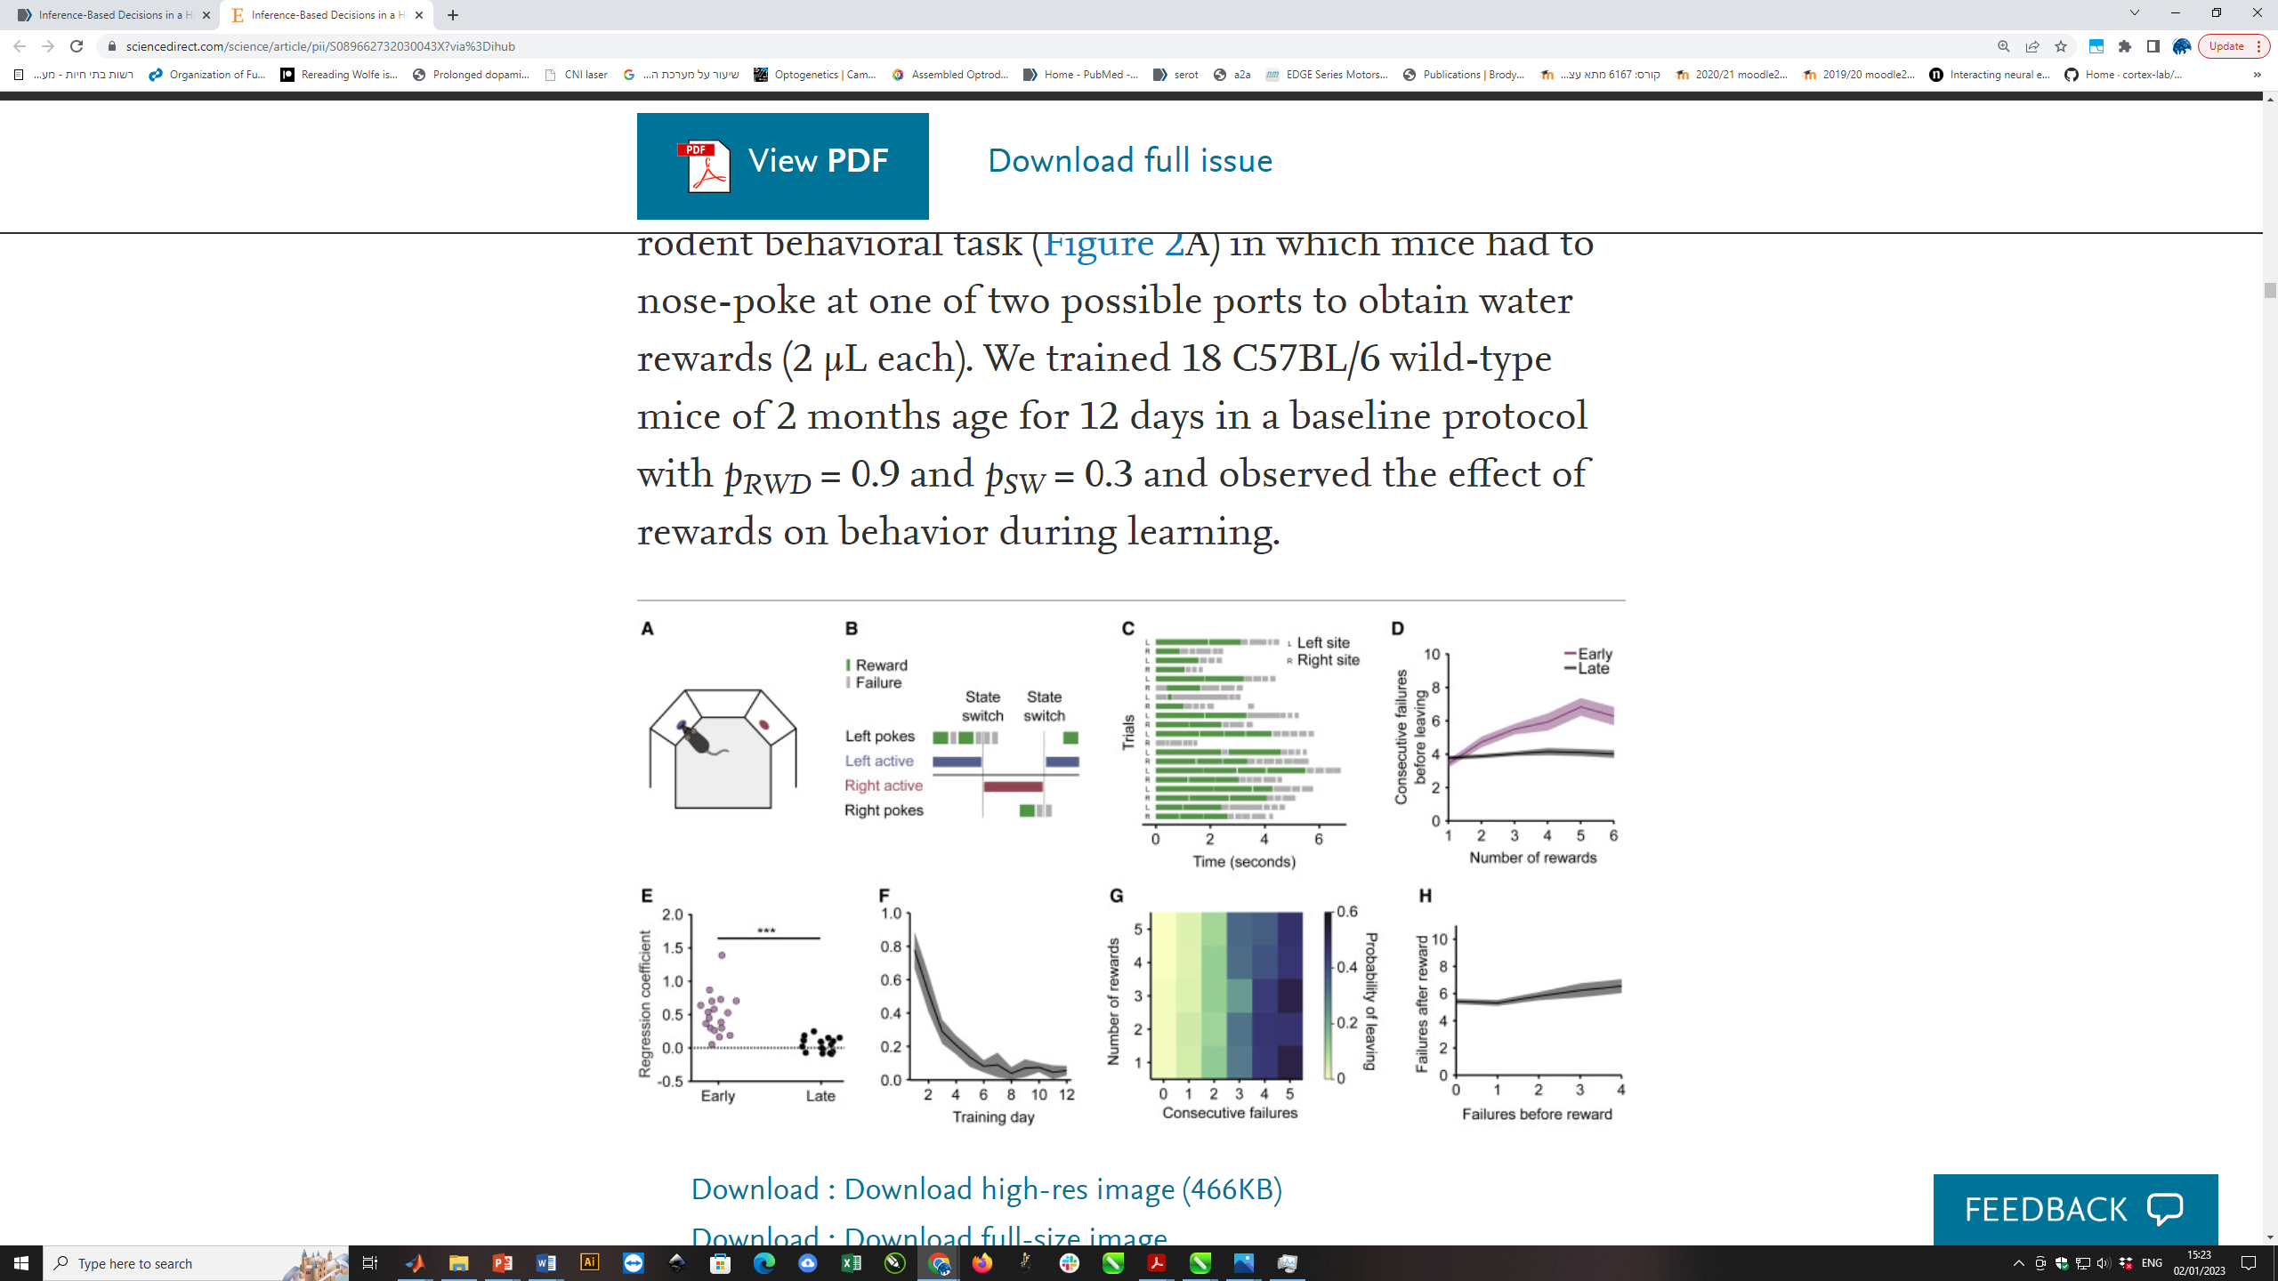Activity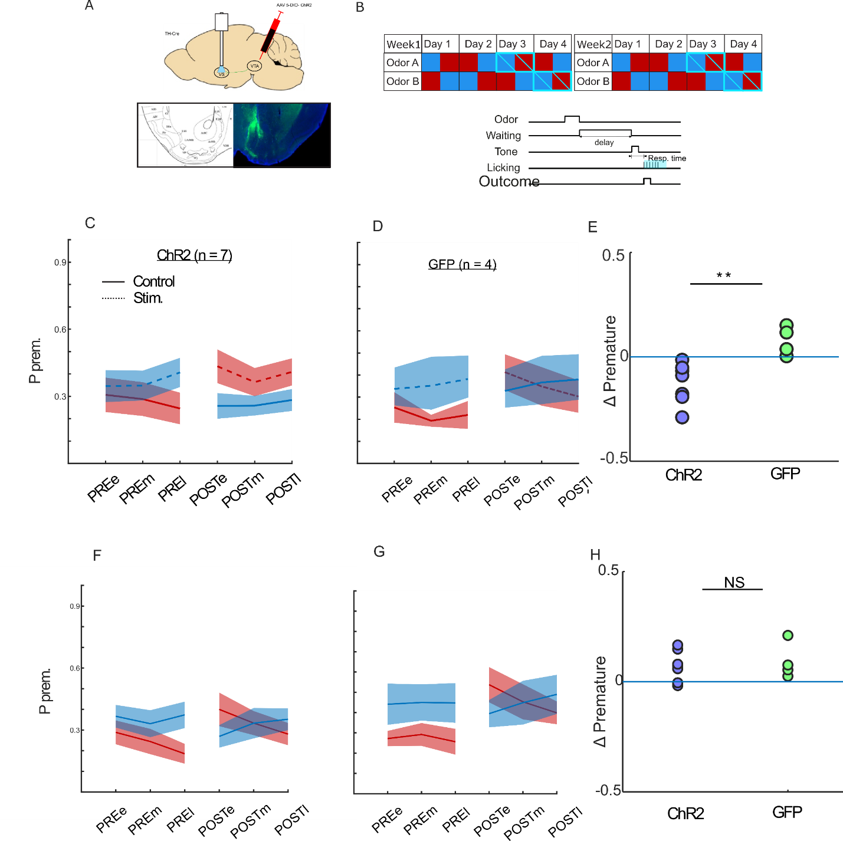

However, even if the animals correctly alternated between the right and left ports, not all nose-pokes were rewarded. Instead, each attempt was rewarded with some probability (either 0.8 or 0.2). Furthermore, port-reward probabilities changed in blocks, such that when the left port was giving reward with 0.8 probability, the right port was set to 0.2 and *vice versa*. Note that block switches were not signaled to the mice.

Additionally, the mice were infected with a virus containing GCaMP6, and the activities of dopaminergic axons within the ventral striatum were monitored through an implanted fiber-optic cannula (this technique is called fiber photometry).

**Data structure:**

* trial_number
* reward: 0=Omission, 1=Reward
* side: 0 or 1
* reward_prob: 20 or 80, switches in blocks
* green: vector of photometry signal (6001, in ms)

**Question 1. Responses to rewards and omissions**

(a) In this analysis, you will compare dopamine signals between reward and omission trials. To visualize the results, start by creating two heatmaps (one for reward trials and one for omission trials), where the x-axis represents time relative to nose-poke, the y-axis indicates trial number, and the color scale represents signal intensity. Next, plot the average dopamine response traces for reward and omission trials. Finally, generate a bar graph showing the average dopamine responses within a 1-second time window after nose-poking, and conduct a statistical test to compare the two conditions.

(b) Do these results align with the reward prediction error (RPE) theory of dopamine? Propose an alternative explanation for the observed findings.

**Question 2. Responses to reward prediction errors**

(a1) In this analysis, you will test the predictions of the dopamine RPE hypothesis in the data. Plot the reward responses for the 0.2 and 0.8 reward probability trials, displaying only the average response traces. Heatmaps, bar plots, and statistical analyses are not required.

(a2) Plot omission responses for the 0.2 and 0.8 reward probability trials following the same format.

(a3) Do these results (qualitatively) align with the predictions of the RPE hypothesis? Provide a brief explanation.

(b) Since reward probabilities are not explicitly signaled, the results in section (a) must be attributed to trial history. Perform analysis to demonstrate that RPE coding relies on the mouse's experience, independent of explicit reward probabilities (which were unknown to the mouse).

(Bonus) In this task, the reward probabilities on the two sides are anticorrelated—when one side becomes more rewarding, the other becomes less so. However, this need not always be the case; for example, the two reward probabilities could have been independent. Can you identify evidence that dopamine signals are sensitive to this specific task structure? Briefly discuss the implications of your findings for the mouse’s learning strategy.

**Submission Guidelines:**

Submission due to: **18/1/2025**

* Submit all your answers and figures as one merged PDF file.
  + Please review the file and see if it’s readable
* The code should be submitted separately as an **executable** file (.m or .py).
  + Please document your code
* Indicate the number of the question and section at the beginning of each part of your answer.
* Submit all answers and figures in the order they appear in the exercise.
* Make sure you explain the results you got in all questions. Explain what you see in each figure.
* Make sure to indicate labels and units on the axes of the graphs.
* Answers may be given in English or Hebrew.

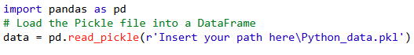In your analysis, you may use Python/MATLAB. Please use the corresponding data file according to your choice.  
* For loading the ‘Python_data.pkl’ file, please use the following: